HARIPRIYADHARSHAINI V



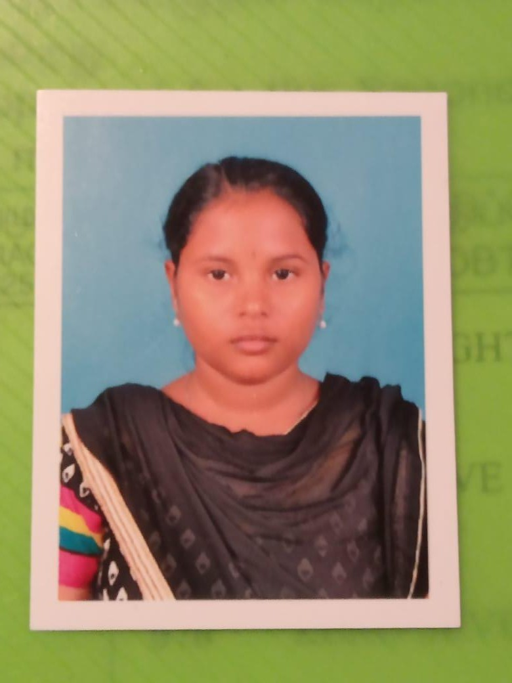Contact No : 7010269541

Email ID : [haripriyavenkadachalam@gmail.com](mailto:haripriyavenkadachalam@gmail.com) Address : 5/72, Kailasam Palayam,Vadugam-po,

Rasipuram-TK, Namakkal - 637 407.

# Carrer Objective

I am seeking opportunities to join a company that can help me in enhancing my skills, strengthening my knowledge and realising my potential. I am willing to explore a wide variety of opportunities that can help me gain perspective ***.***

# Academic Qualifications

|  |  |  |  |  |
| --- | --- | --- | --- | --- |
| **Course** | **Name of the Institution** | **Board of Study** | **CGPA /**  **Percentage** | **Year of Passing** |
| B.Tech Information Technology | Muthayammal Engineering college | Anna university | 6.98(CGPA) | 2023 |
| HSC | Govt Higher Secondary School, R.Pattanam, Namakkal. | State Board | 59.6% | 2019 |
| SSLC | Govt Higher Secondary School, R.Pattanam, Namakkal. | State Board | 80% | 2017 |

**Project**

* **Title :** Tic Tac Teo Game
* **Objective :** It’s a Funny Game
* **Tools Used :** HTML, CSS

# Professional Proficiency

* Programming Languages Known : Java
* Scripting Languages Known : HTML, CSS, JS
* Query Language Known : SQL
* Software’s Known : Visual Studio Code, Eclipse-IDE

# Curricular Activities

* **Certifications**
  + I have completed AWS Cloud Fundamental Course in AWS Platform.
* **Workshop**
  + Attended One day workshop on “Role of Python in Data Analytic and Business Intelligence” Organized by Muthayammal Engineering College, Rasipuram.

# Personal Proficiency

* Time Management
* Self motivated
* Leadership
* Adaptability

# Personal Dossiers

* Parent’s Name : Mr. A.Venkadachalam, Mrs.V.Parvatham
* Date of Birth : 21/06/2002
* Blood Group : O+ve
* Marital Status : Unmarried
* Languages Known :

|  |  |  |  |
| --- | --- | --- | --- |
| **Language** | **Read** | **Write** | **Speak** |
| Tamil | ✓ | ✓ | ✓ |
| English | ✓ | ✓ | ✓ |

# Declaration

I hereby declare that the details above furnished by me are true to the best of my knowledge and belief.

Date : Signature

Place :Rasipuram (HARIPRIYADHARSHINI V)